VEERENDRA KUMAR JAISWAL
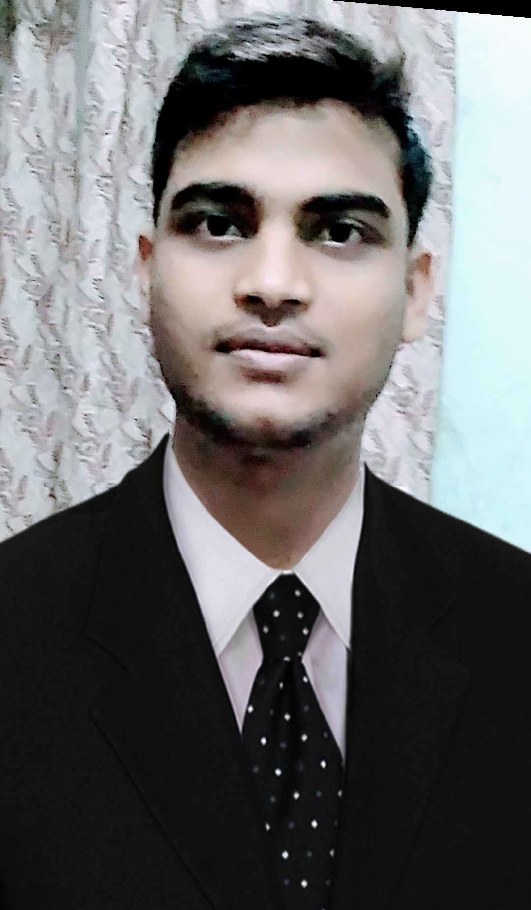
Add. :- 79 Koylari, Post-KuteswarMinse,
Satna M.P. (485747)
Email:- veerendrajaiswal910@gmail.com
Contact No:- +91-9300138918

CAREER OBJECTIVE
- To work with complete dedication and ensure optimal utilization of company resource with my skills to achieve organisational goals.

Educational Qualification
- Post Diploma In Tool & Die Manufacturing
Indo German Tool Room, Aurangabad
Period: 2016-2017 (Percentage : 70.75%)
- Bachelor of Engineering- Mechanical
Shri Ram Group of Institutions, Jabalpur (RGPV ,Bhopal)
Period: 2012-2016 (CGPA: 7.31)
- Higher Secondary Education.
Hitkarni H S School, Govindganj, Jabalpur(M.P.)
Session: 2011-12 (Percentage : 69.6%).
- High School Education
Sukirti H S School, Doli, Katni (M.P.)
Session: 2009-2010 (Percentage : 73%)

ACADEMIC PROJECT UNDER DEGREE
Project Title :- Automatic Metal Grinding Machine
Subject. :- Mechanical based

PROFESSIONAL TRAININGS
- Training of 8 months from Indo German Tool Room, Aurangabad
Focus Areas:
- Assembly Department
- Press Tool Assembly
- Die Casting Assembly
- Mould Tool Assembly
- Precision Department
- CNC Milling
- CNC Lath
- CNC WireCut
- CNC EDM
- CAD/CAM Software Training From IGTR, Aurangabad
- AutoCad
- Master CAM
- Delcam
- Training of 15Days from Vehicle Factory Jabalpur (M.P.)
Focus Areas:
Gear Hobbing.
Vehicle Assembly.
Heat Treatment

TECHNICAL SKILLS
Production Planning and Control
Production & Manufacturing Techniques
Strength of Materials
Basics of C& C++
MS Office

EXTRA CURRICULAR ACTIVITIES
School Minister in School.
Social work leader
Member of Blood Donation group “We are Blood Doner.

PERSONAL DETAILS
Name : Veerendra Kumar Jaiswal
Father’s Name : Mr. Vishwanath Jaiswal
Mother’s Name : Mrs. Batasiya Jaiswal
Date of Birth : 05 Aug 1994
Languages Known : English & Hindi
Hobbies : Playing Cricket & Badminton.

DECLARATION
I here by declare that all the particulars given above is true to the best of my knowledge & belief.

Date : 23-07-2016
Place : Jabalpur Veerendra Ku. Jaiswal

